Running head: CLASSIFICATION IN ORGANIZATIONAL RESEARCH

Text Classification in Organizational Research: A tutorial
Vladimer B. Kobayashi
Stefan T. Mol
Hannah A. Berkers
Gábor Kismihók
Deanne N. den Hartog
Center of Job Knowledge Research/HRM-OB Group
Amsterdam Business School
University of Amsterdam

Abstract

Text Classification in Organizational Research: A tutorial
What has come to be known as "unstructured data" in organizations are primarily comprised of text data. In contrast with data that are arranged in rows and columns as is typical of most numerical data or data that are stored in relational databases, text data are often coded in plain free text. Text data are pervasive since one of the primary means of communication within and between organizations is through written text. Interest in text data is increasing due to their quantity, their richness, and their utility as an aid for interpretation in quantitative studies. Examples of text that originate from organizations include company reports, e-mail messages, memos, and hiring offers. Since the arrival of digitalization, the quantity of text generated per day has been unprecedented. For emails alone, based on a recent estimate, the number of sent and received emails per business user averages to 122 emails per day (The Radicati Group, Inc., 2015). The insights that may be gained from text data are diverse, since text data convey meaning (Hsieh & Shannon, 2005), intentions (Popping, 2012), and emotions (Pang & Lee, 2008). Lastly, the utility of text as an aid for interpretation in quantitative studies is apparent from the practice of using text to develop description and explanation as a way to supplement analytical findings from numerical data. Although, many organizations analyze text data in some shape or form, most approaches rely on manual procedures (e.g. manually annotating documents) which may become cumbersome for even a few hundred documents. Thus, computer-aided procedures are needed in order to accelerate the analysis of text (G. Salton, 1970).
Traditionally, organizational researchers derive meaning from text by applying qualitative approaches (Duriau, Reger, & Pfarrer, 2007; Hsieh & Shannon, 2005). Most of these techniques require the researcher to manually annotate text. In template analysis, bits of text are assigned to one of the pre-constructed themes or codes (King, 1998). For large collections of text, manual procedures become laborious and painstaking, and at times physically prohibitive, even with the use of existing software for qualitative data analysis. Moreover, manual coders may get exhausted and their performance and consistency may degrade over time, hence negatively affecting coding reliability. One workaround is to sample the text corpus as opposed to coding everything. However, this comes with the cost of accidentally omitting important information, thus reducing the internal and external validity of the results. Another solution is to hire additional coders but this entails cost, training, and verification to ensure inter-rater reliability. In case there is an impetus to analyze all of the available text, and the amount of text data is large, a procedure that can reliably and efficiently assign text elements to classes is desirable. The procedure is then programmed to a computer to facilitate automatic text assignment.
Text mining, defined as the automatic extraction of patterns from text, offers numerous procedures (also known as algorithms) that have the potential to automate activities that are often performed manually by qualitative researchers who analyze text. Algorithms for theme extraction (Zirn & Stuckenschmidt, 2014) and text classification (Harish, Guru, & Manjunath, 2010; Y. H. Li & Jain, 1998) have found applications in document retrieval, topic classification, document routing (e.g. automatic distribution of emergency call records to appropriate departments for resolution) (Eyheramendy et al., 2003; Feng, Guo, Jing, & Hao, 2012) and filtering systems. The process of algorithm development requires researchers to explicitly express the manner by which they assign units of text (ranging from single words to several sentences in length) to classes, hence maintaining consistency and therewith reliability (Duriau et al., 2007).
In general, a text mining solution consists of two consecutive parts (Harish et al., 2010): (1) the preprocessing and transformation of text and (2) the specific analytical procedure that is subsequently applied to the transformed text (e.g. classification algorithm). From its plain free form, text is preprocessed and transformed (Palmer, 2010; Scott & Matwin, 1999). Although preprocessing and transformation can be viewed as distinct steps, they are actually interlinked and they have far reaching influence on the succeeding steps such as in classification performance (Uysal & Gunal, 2014; Yang & Pedersen, 1997). A more thorough discussion of these steps will be presented later in the paper.

This paper focuses on text classification (TC) for the following three reasons. First, text classification encapsulates many applications of text mining that may be applied in organizational research, such as sentiment analysis (Pang & Lee, 2008), short text classification (Faguo, Fan, Bingru, & Xingang, 2010; Phan, Nguyen, & Horiguchi, 2008; Vo & Ock, 2015), and sentence classification (Khoo, Marom, & Albrecht, 2006). Second, text classification techniques may help researchers of textual data to automate the manual assignment of text to classes which will inevitably lead to time and cost savings (Braun & Clarke, 2006; Hsieh & Shannon, 2005; King, 1998). Third, in our experience, many researchers from different fields have data that are amenable to text classification, perhaps without realizing it. With this article, we hope to encourage the uptake of text classification on the part of the organizational research community. Vice versa, we believe that apart from being mere users, organizational researchers can contribute insights that can motivate developments in and augment the practical value of text classification.
As a reading guide, this paper has two main subdivisions. The first part is a discussion of specific concerns and recommendations in each step of text classification, namely, (1) preprocessing, (2) transformation, (3) dimensionality reduction, (4) application of classification techniques, (5) evaluation and (6) model validation. Existing studies are used to enrich and illustrate this discussion. The second part is a hands-on tutorial on text classification through our own work where text classification is used to address the challenge of extracting job task information from nursing job vacancies. The demonstration of the validity of text mining outcomes in the form of classification models will likely be a critical antecedent for the adoption of text mining by the organizational research community. Hence, we will illustrate how to establish model validity in this context. Specifically, we establish model validity in two ways, assessing the validity through examining the choice of features and classification algorithm and through the output of the classification.
The tutorials on classification that have appeared so far (Ghosh, Roy, & Bandyopadhyay, 2012; Harish et al., 2010; Y. H. Li & Jain, 1998; Sebastiani, 2002) have been targeted mainly towards researchers active in the field of machine learning and data mining. This has resulted in a skewed focus on technical details on the conduct of classification as opposed to a more balanced treatment of techniques and an examination of the validity of its outcomes. Since the latter is likely a fundamental interest to organizational researchers who want to incorporate classification in their own research, we set out to i) increase the accessibility of text mining to the organizational research community by providing step by step guidance in the text mining process, followed by ii) organizational research specific guidance on establishing reliability and validity of text mining.

Text Classification
Text classification (TC) is defined as the automatic assignment of text to predefined classes (Y. H. Li & Jain, 1998; Sebastiani, 2002). In practice, researchers often talk about the assignment of classes to text (i.e. text coding or annotation), this as well is a form of TC (Cardie & Wilkerson, 2008; Erdmann, Maedche, Schnurr, & Staab, 2000; Wilson, Arledge, Ford, & Rust, 1993). Classes may either be defined by the researcher or be based on an existing classification taxonomy. In the simplest case, text is assigned to either one of two classes, i.e. binary classification. For example, in sentiment analysis, an opinion phrase about product features is assigned to either positive or negative sentiment (Popescu & Etzioni, 2007). Before we continue, we disambiguate the term document. Here, document refers to the unit of analysis in the context of analyzing text. Thus, hereafter the word document means the textual unit of analysis. It can be a sentence, a paragraph or a whole literary work. In TC, the assignment of documents to classes is made by applying a classification model (also known as a classifier). The model is constructed (or trained) using a set of documents whose classes are known (i.e. training data). New documents are classified by applying the trained classifier.
The core challenge for TC is to program a computer to simulate how humans interpret text. This is done by emulating the process by which humans recover the underlying meanings embedded therein and expressing this in unambiguous and precise instructions that can be run on a computer. Addressing this challenge is not easy since natural languages possess high-level semantics and abstract concepts (Harish et al., 2010; Popping, 2012) that may be difficult to articulate in computer language. For instance, a single concept may be represented in various ways through the use of synonyms. Vice versa, polysemy refers to the same word having very different meanings (Guo & Diab, 2012; Landauer, Foltz, & Laham, 1998). Furthermore, text data may contain structural ambiguity, and some sentences are written in the active voice and others in the passive (Popping, 2012). Determining the type of voice is thus essential to determine which concept is being emphasized. A final issue pertains to how to deal with typographical errors or misspellings contained in text (Dave, Lawrence, & Pennock, 2003; G. Salton, 1970). These sources of ambiguity are tacitly addressed when humans read and interpret text, but in automatic TC, strategies for dealing with synonymy, polysemy, active vs. passive voice, and typographical errors and misspellings all need to be explicated during the development of a classifier. here are other lexical and syntactambes inassifiers address
Before a text classifier is ready to be deployed it thus needs rigorous training and testing, fine tuning, and repeated evaluation until an acceptable level of performance is achieved or validity is established. The resulting classifier is expected to approximate (or exceed) human classification performance (Powers, 2011; Williams & Leggett, 1984). Thus, TC, and classification in general, centers on addressing concerns related to performance, reliability, and efficiency (Forman, 2003; Sun & Lim, 2001; Yang, 1999).

***************Potential Applications of TC in OR***************
Deanne or Stefan or Gabor
**********************************************************

TC: The Process
In this and the succeeding sections, the TC process and some of the challenges one may encounter during the process are discussed. The TC process starts with training data preparation. This means that the documents of interest are collected either from the Web or from companies' data repositories. Here, it is assumed that classes are already constructed and the researcher has access to a set of documents whose classes are known (i.e. the training data). For example in spam email classification (Metsis, Androutsopoulos, & Paliouras, 2006) by manually classifying messages as spam or ham. The size of the training dataset is dependent upon the cost associated with acquiring pre-labelled documents and whether the pre-labelled documents provide enough data to train a classifier (Beitzel et al., 2005; Toutanova, Chen, Popat, & Hofmann, 2001). In our work, we usually label a few hundred documents and we make sure that the number of documents in each class are roughly equal. The objective is to build a classifier that can correctly classify new and un-labelled documents.
Once the training text data have been compiled, the documents are preprocessed. This step includes text cleaning where irrelevant parts of the documents are filtered out and inconsistencies are resolved (Palmer, 2010; Rahm & Do, 2000). Words that do not have semantic content are deleted and individual words are transformed to resolve differences in spellings. Moreover, words expressing the same concept or idea are merged together under a single representation (Dave et al., 2003).
The cleaned text data are used as input for the transformation step where documents are converted into a format which facilitates the application of classification techniques. In this step, features are constructed that capture characteristics of the text contained in the documents (Scott & Matwin, 1999). Suppose that documents have been defined at the sentence level. Examples of features that could be considered are whether a sentence contains a number, whether a sentence ends with a specific word, how many words there are in the sentence, or how many times a specific word occurs in a sentence. Thus, features assess specific characteristics of the documents (Flach, 2012, pp. 38–46). Features can essentially be conceptualized as ‘predictors’ of class, and even though each feature (such as for instance sentence length) may only account for a tiny amount of the variance in the class that a particular document has been manually assigned to, it is through the combination of features that text classification becomes a powerful and accurate tool. The definition of features is therefore a crucial step because the choice of features ultimately influence the performance of the resulting classifier (Chen, Huang, Tian, & Qu, 2009; Yang & Pedersen, 1997).
Once documents are transformed, available techniques for classification from statistics, machine learning, and data mining can then be applied. Choosing a specific classification technique is the same as selecting a hypothesis that is used as a basis to model the relationship between the features and the classes. The classification technique is optimally selected in conjunction with a set of features. Here we specifically refer the combination of features and classification techniques as the classifier (see Figure 1).
It is often the case that several classification techniques are tried and the best according to a specific evaluation measure is selected (Ikonomakis, Kotsiantis, & Tampakas, 2005; Kanaan, Al-Shalabi, Ghwanmeh, & Al-Ma’adeed, 2009; Ragas & Koster, 1998). The most popular evaluation measures are the accuracy, recall, precision, and F-measure. There are also measures that make a trade-off between performance and parsimony (e.g. Bayesian Information Criterion). Apart from being used for comparison purposes, evaluation measures also provide an indication of the generalizability of a classifier, that is, the ability of classifier to correctly classify new and unlabeled documents.
The last step ss talidation In this stepathe classification model is validated in two ways. rlTie forst deals with the concern of whether the choice of features and classification technique hy valid (i.e. does it give correct classification?).th Te lacond is whether the prassification made fromofhe model hre valid practically. This isvasually assessed by domain experts through berifying the output of the classifier. Iach step is discussed in more details next.

Text Preprocessing for Classification
The main purpose of preprocessing text is to rid the documents of unwanted words, which may obscure meaningful patterns and subsequently lead to poor classification performance (Rahm & Do, 2000; Uysal & Gunal, 2014). Preprocessing also impacts the resulting dimensionality in the transformation stage. Dimensionality refers to the number of features generated in the text transformation step (Bingham & Mannila, 2001; Guyon & Elisseeff, 2003). For text, the most popular choice of features are the unique words in a collection of documents also called the vocabulary (G. Salton, 1970; Gerard Salton, Wong, & Yang, 1975; W. Zhang, Yoshida, & Tang, 2008). Thus removing irrelevant words will reduce the size of the vocabulary which will in turn lead to lower dimensionality.

In preprocessing, the terms (i.e. the set of unique words, punctuation marks, number digits and/or other characters (such as symbols) that appear in a collection of documents), are identified using a technique called tokenization. In the English language, terms are usually separated by spaces. Hence it is easier to tokenize English documents than Chinese documents, since written Chinese has no standard definition of words and characters are not separated by spaces. Once documents have been tokenized successive preprocessing procedures may be applied.
Punctuations and numbers, if deemed unimportant are removed. Words that do not express meaning such as conjunctions and prepositions are deleted. These words are called stopwords (G. Salton & Buckley, 1988), examples of stopwords in the English language are “and”, “the”, and “of”. If case of the letters are considered irrelevant then it is advised to transform all upper case letters into lower cases. Another preprocessing method is stemming which is defined as the process of obtaining the root or stem forms of derived words (Frakes, 1992; Porter, 1980). The assumption is that words that have a similar root form are identical in meaning. However, stemming leads to a loss of inflection information in words (e.g. tense, gender, and voice). Inflection information may be important to determine the over-all intention of a sentence, that is, whether it expresses judgement, description of events, description of a process, or description of a state of affairs (Popping, 2012; Uysal & Gunal, 2014). Stemming is actually part of a broad class of preprocessing techniques called normalization (Dave et al., 2003; Toman, Tesar, & Jezek, 2006). The aim of normalization is to merge terms that express the same idea or concept under one representation called a template. For example, one can use a template NUMBER to replace all occurrences of number digits in a collection of documents. This can be useful when it is less relevant to take into account specific numbers but nevertheless important to consider if a document contains a number or not.
A practical question is when to use which preprocessing technique? The answer is largely determined by the domain of application and the language of the text (Gonçalves & Quaresma, 2005; Uysal & Gunal, 2014). The domain of application is related to the kind of text one is dealing with. For example if the domain of application is spam email classification then the documents are the email messages (Youn & McLeod, 2007). Or if one is interested in classifying online news then the documents are online news articles (Hayes, Knecht, & Cellio, 1988). Each has its own characteristics. As a comparison, email messages are relatively shorter than online news articles; news articles are often description of events or state of affairs and aimed at a general audience, whereas email messages communicate more personal messages; they use different vocabularies; typographical errors occur more frequently in emails than in news articles and so on. The same can be said of language; text written in one language is notably different from text written in another language. One preprocessing procedure may be useful for a specific domain of application and language but not for others. For example, stemming has been shown to improve classification accuracy in one language (Torunoğlu, Çakırman, Ganiz, Akyokuş, & Gürbüz, 2011) but degrades the accuracy in another language (Toman et al., 2006). Hence both should be considered during the preprocessing stage. Next we offer some recommendations.
In the classification of English online news, the impacts of both stemming and stop-word removal are negligible (F. Song, Liu, & Yang, 2005). In general, English and Czech documents classification benefit from stop-word removal but may suffer from word normalization (Toman et al., 2006). For the Arabic language, stemming improves classification performance (Larkey, Ballesteros, & Connell, 2002). In online Turkish news the effect of stemming and removal are small however effects are visible when the training data size is small (Torunoğlu et al., 2011). An English spam email filtering works well without stemming and stop word removal. It has been found out that spam emails contain less stopwords than legitimate emails (Méndez, Iglesias, Fdez-Riverola, Díaz, & Corchado, 2006).
For the majority of cases in English documents, as a recommendation, after word tokenization, convert upper case letters to lower case, and apply stop-word removal (except perhaps for short documents such as email message or product titles) (G. Song, Ye, Du, Huang, & Bie, 2014). Do not use stemming if the classification task is highly sensitive to minor details of language such as when the tense and mood of words are important for the analysis (Thelwall, Buckley, Paltoglou, Cai, & Kappas, 2010).

Text Transformation
Text transformation is a representation problem in the language of text mining. In this case, it comes down to how to represent documents so that they can be a suitable input to a classification algorithm. In essence, this comprises imposing structure on a previously unstructured text. Most classification algorithms accept vectors or matrices as input. Thus the most straightforward way is to represent a document as a vector and consequently represent the collection of documents as a matrix.
The most common way to transform text is to use the so-called bag-of-words model where a document is represented as a multiset of words (Frakes & Baeza-Yates, 1992). An equivalent algebraic representation is the vector space model where documents are represented as vectors (G. Salton, 1970). The size of the vector is equal to the size of the vocabulary. Hence, the features in this representation are the individual terms. This somehow makes sense under the assumption that words are the smallest independent meaningful units of a language. The entries in the document vector correspond to the weights of the terms in that document. The weights can be the raw frequencies of the terms in a document or can be a simple 1 or 0 (i.e. binary weighting), that signifies whether a particular term occurred in the document (1) or not (0).
Although the vector space model may oversimplify the meaning of text, in that the order of words in the document is ignored, many classifier systems rely on it (Joachims, 1998). Ignoring word order means losing some information regarding the syntactic and semantic relationships between words. Also, words alone do not always express true atomic units of meaning. Some researchers address this problem by adding phrases as features (Houvardas & Stamatatos, 2006; Wang, McCallum, & Wei, 2007). Although this incorporates some level of word order information it also leads to explosion of the number of features. If there are unique words the number of potential phrases consisting of two words is approximately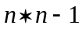 . Also, many phrases do not occur often, which means that their over-all contribution to the classification is negligible (Dave et al., 2003; Hu & Liu, 2004). Finally, adding phrases may add redundant and noisy features. A workaround to this is using only the most informative phrases (e.g. frequent phrases) (Scott & Matwin, 1999). There are strategies for selecting phrases such as applying a noun phrase (Lewis, 1992) or key phrase (Turney, 1999) extraction algorithms. However, this adds additional complexity in the analysis which may not result in a significant improvement in the classification. In fact, many studies show that using syntactic phrases does not demonstrate much improvement over single word-based features (Scott & Matwin, 1999). Thus, when there is no strong need to do so, the recommendation is not to use phrases but to rely on the vector-space model instead.
In the case of choosing the appropriate weight, there are other options to specify the weights of a term aside from the frequency and binary weighting. One can take the logarithm of the frequencies in order to dampen the effect of highly frequent terms. Also, a normalizing factor is applied to adjust for document length (e.g. dividing by the maximum frequency). Apart from the weights of the terms in each document, terms are also weighted with respect to the corpus. The two types of weights are combined such that the over-all weight both reflects the importance of a term in a document and in the corpus. Common corpus-based weights include the document frequency (DF) which signifies the discriminating power of the term (Yang, 1999). Terms that occur in too few or in too many documents are not useful for classification purposes. The most popular combined weight measure in text classification is the product of term frequency (tf) and the inverse document frequency (idf) (Aizawa, 2003). The inverse document frequency assesses the specificity of the term, thus the idf of an extremely common term is close to zero.

A classification model is only as good as its set of features hence text transformation plays a crucial role in determining classification performance. Along the transformation, it is inevitable that some aspects of the text are lost (G. Salton, 1970). Thus, when the resulting classifier does not perform well, it is recommended that the researcher re-examines this step.
In summary, the selection of features requires extensive domain knowledge. The features should capture the content of the document and should satisfy the choice of the researcher of what is important for the domain of application.

Reducing Dimensionality
Even after preprocessing, transformation is still likely to result in high dimensionality. A large number of features is undesirable because it may increase computational time and may degrade classification performance especially when there are many redundant and noisy features (Forman, 2003; Guyon & Elisseeff, 2003; Joachims, 1998). A good strategy is to try to reduce the dimensionality by getting rid of some features or by merging features through feature transformation. A reduced feature set has several advantages including reduced complexity and more interpretable results.
One way to eliminate features is to first assign scores to each feature and then remove features based on a cut-off value (Lan, Tan, Su, & Lu, 2009; G. Salton & Buckley, 1988). The weights from the transformation steps are sometimes used to score the features. An example is to remove features with low idf or low DF since they are deemed non-informative and they possess little discriminatory power. Other strategies make use of the class membership information in the training data to score features as such they are called supervised scoring methods (Lan et al., 2009). Examples of measures that use class membership information are mutual information (MI), chi-squared (CHI), gini index (GI), and information gain (IG) (Lan et al., 2009; Yang & Pedersen, 1997). Unsurprisingly, supervised scoring methods perform better than unsupervised ones (e.g. DF) though in some cases DF thresholding yields comparable performance as that of some of the supervised scoring methods such as CHI and GI (Yang, 1999).
The relevance of a feature is judged in conjunction with an evaluation measure for classification performance (Forman, 2003). Thus, one scoring method may perform well if used in conjunction with a specific evaluation measure (e.g. accuracy) and may perform poorly with another (e.g. precision). CHI and IG demonstrated good performance for the topic classification of online news and subject classification of academic publications given that precision is the evaluation measure (Forman, 2003). IG has also showed competitive performance in conjunction with F-measure and accuracy in the tasks of classifying statute documents and computer science abstracts (Forman, 2003). It seems that IG is an effective measure for feature selection, thus one is advised to try this before using other complicated measures. One caveat, is that IG does not seem to perform well when the classification problem is highly imbalanced because it favors the selection of rare terms (Ogura, Amano, & Kondo, 2011).
Another approach to reduce the size of the feature set is to apply feature transformation techniques such as Principal Component Analysis (PCA) and Latent Semantic Analysis (LSA) (Burges, 2010; Fodor, 2002; van der Maaten, Postma, & van den Herik, 2009). Both construct new features as a linear combination of the original features with the property that the new features are uncorrelated, thus addressing the problem of redundant features. LSA improves upon the vector space model since LSA can detect synonymy (Landauer et al., 1998). Words that appear together and have high contribution in one factor may be considered as synonyms. The new latent features, or factors, replace the original features and are subsequently used in the successive steps. We will discuss more about LSA in the tutorial part.

Application of Text Classification Algorithms
The transformed text (assuming that dimensionality reduction has already been applied) is used as input to various classification algorithms. Most of the algorithms are borrowed from the fields of machine learning and statistics. There are three general types of algorithms: (1) geometric, (2) probabilistic, and (3) logical (Flach, 2012).
Geometric algorithms assume that the documents can be represented geometrically (e.g. as points in hyperspace). Usually it means that distances between documents are defined along with the concept of length. Documents that are similar are closer together than documents that are not. Examples of geometric classifiers are nearest neighbors (Jiang et al., 2012) and support vector machines (Joachims, 1998). Classification is done by first finding in the training data documents that are most similar to the new document (Jiang, Pang, Wu, & Kuang, 2012). Then the majority class of the most similar documents is the class to which the new document is assigned.
Probabilistic algorithms model the relationship between the features and the class as a probability distribution. The documents are assumed to be generated from this distribution through a random process. Class membership for a particular document is obtained by finding the most likely class given the features of the document. Naive Bayes (Eyheramendy et al., 2003) and logistic regression (J. Zhang, Jin, Yang, & Hauptmann, 2003) fall under this type of algorithm.
The last type of algorithm are the logical classifiers which are so called because classification is performed by means of logical rules (Dumais, Platt, Heckerman, & Sahami, 1998; Rokach & Maimon, 2005). Example of such rule is. Logical models have the distinct advantage of being easily interpretable. A prime example of a logical classifier is a decision tree (Rokach & Maimon, 2005).

Naive Bayes and Support Vector Machines are the popular choices (Ikonomakis et al., 2005; Joachims, 1998; Y. H. Li & Jain, 1998; Ragas & Koster, 1998; Sebastiani, 2002). Both are efficient when it comes to dealing with a large feature set and both are able to exploit data sparsity, though in Naive Bayes appropriate smoothing should be applied to adjust for very rare terms.
Other classifiers that have been applied to text classification are Nearest Neighbours, Logistic regression, neural network, linear discriminant analysis, and decision trees. The method of nearest neighbour works well when the amount of training data is large. Both Logistic regression and discriminant analysis yield good performance if the features are transformed using Latent Semantic Analysis. The performance of decision trees has been unsatisfactory, however, when several decision trees are combined in what is called an ensemble approach (Y. H. Li & Jain, 1998), performance has been shown to significantly increase. In fact, many researchers advocate the strategy of training several classifiers to increase classification performance (Breiman, 1996; Dong & Han, 2004; Houtekamer & Derome, 1995; Polikar, 2012). The classification of each classifier are aggregated to come up with a single classification. Some aggregation approaches include the use of simple voting or a weighted approach (Houtekamer & Derome, 1995).

Evaluation Measures
Crucial in any classification task is to define how to assess the performance of classifiers (Powers, 2011; Yang, 1999). This will give an indication whether a classifier is good enough to replace a human labeler (i.e. reliable) and whether the hypothesized relationship between the features and class membership holds true. Classifier performance is also used to compare several classifiers in order to select the best one (Alpaydin, 2014, pp. 37–41). Probably the most straightforward evaluation measure is the accuracy measure which is calculated as the proportion of correctly classified documents. Accuracy ranges from 0 to 1 (or 0 to 100 if expressed in percentages). The higher the accuracy the better the classifier (1 corresponds to perfect classification). However, in some applications, accuracy may not be a good measure especially when classes are skewed (i.e. there is one class to which only few documents belong). An example is in insurance fraud detection (Ngai, Hu, Wong, Chen, & Sun, 2011; Tennyson & Salsas-Forn, 2002). Given that only a small fraction of insurance claims are fraudulent (suppose 0.05), a classifier will still have a high accuracy (equal to .95) even if that classifier classifies all claims as non-fraudulent.
Alternative measures to accuracy are precision, recall, and F-measure (Powers, 2011). In binary classification, the classes are commonly referred to as positive and negative. Classifiers are trained with the aim of correctly identifying observations in the positive class. Precision is computed by the number of correctly identified positive documents (true positives) divided by the total documents identified as positive. This measure is preferred when it is more important to detect documents belonging to the minority class. The minority class is treated as the positive class. Recall on the other hand is the number of correctly classified positive documents divided by the true number of positive documents. In the example about insurance claims, the positive class is the fraudulent class. In this example precision is the number of true fraudulent claims identified by the classifier divided by the total number of fraudulent claims identified by the classifier. Recall is computed by dividing the number of correctly identified fraudulent claims by the total number of actual fraudulent claims. The F-measure is the harmonic mean of recall and precision. Although these three measures are best suited for binary classification (i.e. only two classes), they can be extended for classifications with more than 2 classes by breaking the classification into several 2-class problems. This can be done by considering one class as the positive class and merging the other classes to obtain the negative class. The final values for the measures are the average of the individual 2-class problems.
Evaluation measures, as has been hinted previously, are also used to assess the quality of the features. Thus, one can probe different combinations of feature sets and classification techniques to determine the best combination, i.e. the one which gives highest value for the evaluation measure. Apart from classification performance, a measure can also take into account the complexity of the trained classifier. The size of the feature set contributes to the complexity of a trained classifier. In line with Occam’s razor, when two classifiers have the same classification performance, the one with the lower number of features is preferred (Shreve et al., 2011).
Note that to compute an evaluation measure, the true classes of the documents must be known. Hence, part of the labelled data should be set aside for evaluation. It is not advisable to use all labelled data to train the classifier since this might result in poor external validity (or overfitting). A standard method to validate a classifier is to use -fold cross-validation (Kohavi, 1995). This method splits the labelled dataset into parts. A classifier is trained using 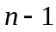 parts called training data and evaluated on the remaining part called test data. This is repeated so that each of the parts had been used as a test data. Thus for equals 10, there are 10 partitions of the labelled data and corresponding 10 values for a given measure, the final estimate is just the average of the 10 values.

Model Validity
Figure 1 illustrates that a classification model is comprised of features and the generic classification algorithm (Domingos, 2012). Thus the validity of the classification model can be examined through the choice of features and algorithm.

Many TC applications use the set of unique words as the feature set (i.e. vector space model) based on the assumption that the essence of a document is represented in the (meaning of the) words it contains (G. Salton, 1970). For organizational researchers this way of specifying the initial set of features may seem unusual since features are somehow constructed in an ad hoc manner, that is, without reference to theory. Specifying the initial set of features, scoring features, transforming features, evaluating features, and modifying the set of features in light of the evaluation constitutes a data-driven approach to feature construction and selection (Guyon, Gunn, Nikravesh, & Zadeh, 2008). The validity of the features is ultimately judged in terms of the classification performance of the resulting classification model. But this does not mean that researchers should abandon a theory based approach. If there is a cogent prior knowledge or theory that supports the choice of features then the researcher is encouraged to apply it (Liu & Motoda, 1998, p. 7). Theory can also be used as a basis for assigning scores to features. A word of caution though, do not allow theory to narrow the focus of the feature construction because other interesting features may emerge spontaneously.
The second component, the classification algorithm, is tasked with modeling the relationship between the features and the class membership. Similar to the features the validity of the algorithm is ultimately determined from the classification performance and is also therefore data-driven. The validity of both the features and the classification algorithm establishes the validity of the classification model.
A strategy to further assess the validity of the classification model is to compare the classifications made by the model with the classification of an independent group of human experts. Usually agreement between the model and human experts is quantified using measures of concordance or measures of how close the classification of the two correspond. Using expert knowledge labels are checked against standards. For example in job task extraction from job vacancies one can check with experts or job incumbents to verify whether the extracted tasks correspond to tasks as actually carried out on the job.
Once model validity is established one may start applying the classification model to unlabeled data. However, the model will still need to be reevaluated from time to time. When the performance of a model is not satisfactory, four possible solutions are suggested, (1) add more features or change the existing features, (2) try other classification algorithms, (3) do both, and (4) collect more data or label additional observations.
Tutorial
At this point you are already familiar with the process of text classification and the different issues encountered in the process of applying it. For a concrete treatment of text classification, we now commence with the provision of a tutorial. The purpose is to get a feel about how to conduct text classification and to do this we provide sample data and codes. The tutorial is a scaled down version of our work on job task extraction from job vacancies. As background, our work is to create a classifier that automatically sorts sentences into task or non-task categories. The sentences are from online German language nursing job vacancies. We want to automate the process of classification because in practice we deal with a huge amount of vacancies. The output from text classification can be used as input to other researches such as job analysis and the concomitant development of a job knowledge test.

We used the R software to run text classification since R has ready-to-use facilities in the form of libraries that automate most text classification procedures. We provide the R scripts and data to run each procedure. Both codes and data can be downloaded as a Zip File from Github, the url is https://github.com/vkobayashi/textclassificationtutorial . The R scripts are named in the following format: CodeListing (CL) <number>.R and in this tutorial we referenced them as CL <number>. Thus, CL 1 refers to the script CodeListing_1.R .
All the scripts were test run and are expected to work on any computer (PC) with R and the required packages installed. The tutorial targets researchers who may or may not have prior experience with text classification. However, basic knowledge including how to start R, run R commands and install packages in RStudio, are needed to understand and run the codes. For readers new to R we recommend to follow an introductory R tutorial. There are numerous freely available online resources where one can learn R (e.g. DataCamp, tutorialspoint, etc.)e
This tutorial follows the sequence of steps for text classification as enumerated previously. The schema followed in this tutorial is the input-process-output order, that is, for each step we first mention the input, next we elaborate the process and finally give the output which is often the input for the succeeding step. Table 1 provides a summary of the input, process, and output for each step in this tutorial. Finally, we suggest that the reader should simultaneously run the codes at each step, in this way the reader can clearly see the input and the corresponding output.

Preparing Text

The input for this step are the raw job vacancies. These vacancies are online German nursing jobs obtained from the company Monster Worlwide, Inc. Since the vacancies are webpages, they are in Hypertext Markup Language (HTML) which is a mark-up language for representing content in web documents (Graham, 1995). Apart from the text that we want (i.e., content), raw HTML pages also contain elements used for layout. Hence, this necessitates that we separate the content from the layout, through parsing (Soderland, 1997).
In R, parsing HTML pages can be done using the XML package. This package contains two functions, namely, htmlTreeParse() that can parse HTML documents and xpathSApply() that can extract specific contents from parsed HTML documents. CL 1 installs and loads the XML package, and uses the htmlTreeParse() and xpathSApply() functions.
The contents of the HTML file sample_nursing_vacancy.html in the folder data is imported as a string object and stored in the variable htmlfile. We provide this variable as argument to the htmlTreeParse() function. The parse content is stored in the variable rawpagehtml. The rawpagehtml is the doc argument to the xpathSApply() function which searches for the node that contains the text that we are interested in. In this case it can be found in the div tag of class content. Tags are keywords surrounded by angle brackets (e.g. <div> and </div>). The xmlValue in the xpathSApply() function means that we are getting the content of the HTML element in the body tag. Finally the writeLines() function writes the text content to a text file named sample_nursing_vacancy.txt (in the folder parsed).
In order to extract text from several HTML files, the codes in CL 1 can be put in a loop (see CL 2). The function htmlfileparser() in CL 2 accepts two arguments and applies the same procedures as in CL 1 for each HTML file. The first argument is the name of the folder where the html files are located and the second argument is the name of the destination folder where the extracted text content are written out. Suppose these html files are in the folder vacancypages and the extracted text content are to be saved in the folder parsevacancies. We provide these arguments to htmlfileparser()
. Expectedly, the number of text files generated corresponds to the number of HTML files, provided that all HTML files are well-defined. The text files comprise the output for this step.

Preprocessing Text
This step has two substeps. The first substep is to isolate the sentences in the vacancies, since the sentence is our unit of analysis. The second substep is to apply secondary text preprocessing operations on the sentences. Input for the first substep are the text files generated from the previous step and the output sentences from this substep serve as input to the second substep. The process of automatically separating individual sentences from text is called sentence segmentation (Huang & Zhang, 2009). CL 3 contains functions that can separate sentences from the parsed HTML file in the previous section (i.e. sample_nursing_vacancy.html).
The code loads the openNLP package. This package contains functions that runs many popular natural language processing (NLP) routines including a sentence segmentation algorithm for German language. The German sentence segmentor in openNLP works most of the time, however, it may occasionally fail. For example, if the segmentor encounters the words bzw. And inkl. (which are abbreviations of “or” and “including” respectively in German) then the algorithm will treat the next word as the start of a new sentence.

This is because the algorithm has a rule that when there is a space after a period the next word is a start of a new sentence. In order to adjust for these and other similar cases, we created a wrapper function named sent_tokens(). Another function sent_split() that accepts a string and a string symbol or pattern is created. It searches for matches of the provided pattern within the string and when a match is found it separates the two sentences at this match. For example, some vacancies use bullet points or symbol such as “|” to enumerate requirements. Thus, to separate the enumerated items we can supply the symbols as arguments to the function. Finally, once the sentences are identified the code writes the sentences to a text file where one line corresponds to one sentence.
For several text files, the codes should be run in a loop. One big text file will then be generated containing sentences from all parsed vacancies. Since we put all sentences from all vacancies in a single file, we attached the names of the corresponding text vacancy files to the sentences to trace back the source vacancy of each sentence. Thus, the resulting text file that contains the sentences can be viewed as a data with two columns: the first column is the file name of the vacancy and the second column are the sentences.
Suppose after applying sentence segmentation on the parsed vacancy in sample_nursing_vacancy.txt the sentences are in the file sentencelines_nursing_vacancy.txt located in the folder sentences_from_sample_vacancy. The next task is to import the sentences to R so that additional preprocessing can be performed (e.g. text cleaning). Other preprocessing steps that may be applied are lower case transformation, punctuation removal, number removal, stopwords removal, and stemming. For this we use the tm package in R. Word tokenization is automatically done in this package, thus we no longer need to bother about it. The sentences are imported through R's data importing functions.
The sentences are imported as a data frame in R (see CL 4). Hereafter, we refer to these sentences as documents since the sentence is our unit of analysis. The first column is temporarily ignored since it contains only the names of the vacancy files. Since the sentences are now stored in a vector (in the second column of the data frame), the VectorSource() function is used. The source determines where to find the documents. In this case the documents are in mysentences[,2]. If the documents are stored in another source, for example in a directory rather than in a vector you can use DirSource(). For list of supported sources, invoke the function getSources(). Once the source has been set, the next step is to create a corpus from this source. In tm package, corpus is the main structure for managing documents. Several preprocessing procedures can then be applied to the documents in the corpus. Several of the popular preprocessing procedures are readily available in this package. Apart from the existing ones, users can also specify their own procedures via user-defined functions. The procedures we applied are encapsulated in the transformCorpus() function. They include number, punctuation, and extra whitespace removal, and lower case conversion. We did not apply stemming since previous studies have suggested not to use stemming for short documents (G. Song et al., 2014). Obviously, the output are the sanitized sentences in the corpus without number, punctuation, and extra whitespaces.
For our bigger work, we randomly selected 60,000 sentences and the remaining sentences are set aside for future testing. Hence, the corpus has 60,000 documents. Furthermore, we used the same set of preprocessing. After preprocessing had been accomplished, we now proceed to text transformation.

Text Transformation
Now that the sentences are preprocessed as done above. We turn our attention to transforming the documents structurally (see CL 5). The input in this step is the output from the preceding step which are the sanitized sentences in the corpus. For this, we use the vector space model because this is the most popular approach to quantify text and a good starting point for anyone who wants to apply text classification (Salton et al., 1975). The features for this transformation are the individual words. The tm package has the function DocumentTermMatrix() for doing this.
The Document-by-Term matrix transforms a corpus into a matrix where the rows are the documents, the columns are features, and the entries are the weights of the features in each document. In vector space model, a feature is also referred to as a term. The default behavior of the DocumentTermMatrix() function is to ignore terms with less than 3 characters. Hence, it is possible that some rows consist entirely of 0s because after preprocessing it may be the case that in some sentences all remaining terms have less than 3 characters. Thus, the bare output in this step is the constructed Document-by-Term matrix. This matrix can be used as basis for further analyses such as keyword extraction or can be further manipulated such as performing weight adjustments.
We mentioned previously that for word features one can use frequencies as weights. Since weight is taken as an importance measure, the idea of using frequencies is that the more frequent a term is the more is its importance in that document. The DocumentTermmatrix() function uses the raw frequency as default weighting option. One can specify other weights through the weighting option of the control argument. To take into account documents sizes, we can apply a normalization to the weights although in this case it is not an issue because sentences are relatively short. One normalization is to divide all frequencies with the maximum frequency possible in that document. Using Document 3 as example, the maximum term frequency is 2, hence we divide all term frequencies in this document by 2. The new weight for mensch is 1 and terms with frequency 1 now have weight equal to 0.5. The justification for this normalization is that the size of the document is approximately proportional to the frequency of its most frequent term.
In classification it is also essential to assign a "weight" to a feature that reflects its importance with respect to the entire corpus. Terms which occur very rarely in documents are considered non-informative (Yang, 1999). An example of such weight is the document frequency (DF) which is defined as the number of documents in which a term occurs. The higher the DF of a term the more important it is corpus-wise. For our example the words with the highest DF (excluding stopwords) are betreuung and plege.
On the other hand, words that are extremely common possess little discriminatory power, thus they are also not useful for classification. In our example, the German word sowie which translates to "as well as" in English is common but is not useful for this classification. A weighting procedure that allows the measurement of the specificity of a term is the inverse document frequency (idf). Highly common terms have low idf and are also deleted when conducting text classification. Hence in practice, terms with low DF and low idf are deleted. This has an effect of removing extremely rare and extremely common terms.
In some studies, term frequency and idf are combined to derive an over-all weight for terms in each document. The combination is the famous tf-idf measure which is the product of the two weights. It can be interpreted as taken into account the importance of a term in a document as well as its specificity in the corpus. An interesting use of tf-idf is to find keywords in documents. The keywords may be used as a heuristic to determine the most likely topic of each document. The keyword for each document is the word with the maximum tf-idf weight (ties are treated randomly).
The codes in CL 6 compute the keyword for each document. For example, the keyword for Document 4 is aufgabenschwerpunkte which translates to “task focal points”.
The final Document-by-Term matrix can be used as input to dimensionality reduction techniques or to classification algorithms. For our bigger work we applied this transformation for our vacancy data and initially used the raw frequency weighting.
The Document-by-Term can be used as input to dimensionality reduction techniques or to classification algorithms. For our bigger work we applied this transformation for our vacancy data and initially used the raw frequency weighting.

Before attempting to run classification algorithms on the data, let us first investigate which among the features are probably the most useful in this classification. Since the initial features were selected in an adhoc way, that is, without reference to specific background knowledge or theory, it may be possible that some of the features are not relevant for our classification task. This part is called dimensionality reduction because the aim is to obtain a more compact and representative and hopefully smaller set of features. The input for this step is usually the Document-by-Term matrix.
Latent Semantic Analysis is a common technique applied to reduce the size of the feature set (Landauer et al., 1998). It makes use of the assumption that words that convey the same meaning tend to exhibit similar patterns of occurrence in similar pieces of text. The technique is akin to Principal Component Analysis because it applies a Singular Value Decomposition to a matrix. The matrix in this case is the Term by Document matrix (i.e. the transpose of the Document by Term matrix). The output of LSA are new dimensions which reveal the underlying patterns in the original features. The new features can be interpreted as new terms that summarizes the contextual similarity of the original terms. Thus, LSA partly addresses the issues of synonymy and in some circumstances, polysemy (i.e. when a single meaning of a word is used predominantly in a corpus). In R, the lsa package contains a function that runs Latent Semantic Analysis.
To illustrate LSA we need additional vacancies. For illustrative purposes we used a total of 13 job vacancies. The vacancies are in the folder parsedvacancies. We applied sentence segmentation to all the vacancies and obtained a text file containing 477 sentences that were extracted from the 13 vacancies. The file is in folder sentences_from_vacancies. After applying preprocessing and transformation the sentences in sentenceVacancies.txt we obtained 1173 features in total. We selected around 327 sentences (including all task sentences since there are only a few of them) and run LSA to the resulting Term by Document Matrix (see CL7). Here we apply normalization to the term frequencies to minimize the effect of longer sentences
Documents and terms are projected to the constructed LSA space. The projection is in the matrix projdocterms. The entries in this matrix are readjustments of the original entries in the Term Document Matrix. The readjustments take into account patterns of co-occurence of terms. Hence, terms which often occur together will roughly have the same values in documents where they are expected to appear. We can apply the cosine measure to find terms similar to a given term. Similar is interpreted as having the same pattern of occurrence. For example, terms which have the same pattern of occurrence with sicherstellung can be found by running the corresponding commands in CL 8.
The word sicherstellung which means “guarantee” in English is found to be contextually similar to patientenversorgunng (patient care) and reibungslosen (smooth) because these two words appeared together with sicherstellung in the selected documents. Another interesting property of LSA is that it can uncover similarity between two terms even though the two terms may never be found to occur together in the same documents. Consider for example the word koordinierung (coordination), we find that one of its similar terms is cooperative (cooperative) although there is not one document in the corpus where the two terms co-occur. This happens because both terms are found to co-occur with zusammenarbeit (collaboration), thus when either one of the terms occurs then LSA expects that the other should also be present. This is the way LSA addresses the issue of synonymy and polysemy. One can also find the correlation among documents and among terms by running the corresponding commands in CL 8.
Since our aim is to reduce the dimensionality, we want to project the documents to the new dimensions. This is accomplished by the corresponding codes in CL 8. From the LSA, we obtain a total of 117 new dimensions from the original 1173 features. It is usually not easy to attach natural language interpretations to the new dimensions. In some scenarios, we can interpret the new dimension by examining the scaled coefficients of the terms on the new dimensions (much like in PCA, though the values should not be interpreted as correlations). Terms with high values on a specific dimension have more influence on that dimension. Figure 3 visualizes the terms with high numerical coefficients on the first 6 LSA dimensions. Here we make a distinction whether a term has been found to occur in a task sentence (red) or not (blue). In this way, it will give us an indication which dimensions are influential for each class.
One question remains, how to select the number of dimensions in LSA? This is usually answered empirically. When classification performance is the ultimate aim, we need to determine whether the number of dimensions selected has led to improvement in classification. Thus, we need to compare the performance between using the original feature set and the reduced feature set. Other considerations include the complexity of the resulting classification model, amount of time spend on training the model and enhanced model interpretability. Reducing the size of the feature set would almost often lead to reduction in model complexity and training time, however, it may lead as well to low classification performance (e.g. low accuracy). Hence, the researcher should try to balance complexity and performance. When one is lucky, reducing the size of feature set leads to both model simplicity and performance gain.
Automatic procedures can be used to guide the choice of how many dimensions to retain. These include: (1) Setting a threshold to the cumulative proportion of the selected singular values. This is the way we selected the dimensions in this example. We set share=0.5, which means select singular values in sequence (from the first) until the ratio of the sum of the selected singular values over the sum of all singular values exceed 0.5. (2) Use the Kaiser Criterion, where all singular values greater than 1 are selected. (3) Select the singular values in sequence until the sum exceed the specified number of documents.
LSA and other related techniques (e.g. PCA), reduce dimensionality by creating new dimensions which summarize the original features (Burges, 2010). There is another type of approach where no new features are created but we just make a selection from the existing ones. Downsizing the feature set is achieved by eliminating some features which are not relevant. A class of techniques in this approach are collectively called filter methods (Guyon & Elisseeff, 2003). They work by assigning scores to features and setting a threshold whereby features having scores below the threshold are filtered out. Both the DF and idf can be used as scoring methods. However, one main disadvantage of DF and idf is they do not use class membership information in the training data. Using available class membership information could be useful to assess the discriminatory potential of features (Lan et al., 2009). Thus, scoring methods that incorporate class membership (called supervised scoring methods) are preferred over those methods that do not.
For supervised scoring methods, we need to use the labels of the training data. In this example, the labels are whether a sentence expresses task information (1) or not (0). These labels can be obtained by presenting the sentences to experts and the experts will manually choose the appropriate labels for each sentence. For our example, we manually assign labels to the 477 sentences. We apply these three scoring methods in our example (see CL 12). Due to the limited number of labelled documents in the data, these scoring methods seem to yield less optimal results. However, they still managed to find one feature that may be useful for classification, that is, the word betreuung. In the data, this word most often occurred in task sentences. Thus, this word is important in identifying the class of task sentences. The output from this step is a column-reduced matrix that is either the reduced version of the Document-by-Term matrix or the matrix with the new dimensions.
In our example we applied LSA and the output is a matrix where the columns are the LSA dimensions. For our bigger study, we applied LSA and we also used the Random Projection method (Bingham & Mannila, 2001) to reduce the dimensionality of our feature set.

Classification
The reduced matrix from the preceding section can be used as input when we run classification algorithms. Obviously the output from this step is a classification model which we can use to automatically classify new sentences. We have mentioned earlier that reducing dimensionality is an empirically driven decision rather than relying on specific rules of thumb. Thus, we will test whether the new dimensions lead to improvement in performance compared to the original set by running separate classification algorithms on each sets. The classification algorithms we run here are Support Vector Machines (SVMs), Naive Bayes and Random Forest classifiers. These three are found to work well on text data (Dong & Han, 2004; Eyheramendy et al., 2003; Joachims, 1998). SVMs and Random Forest are especially preferred when dimensionality is high.
Traditional accuracy is not a good choice for the performance metric here since the proportion of task sentences in our example data is low (less than 10%). The baseline accuracy (computed from the model which assigns all sentences to the dominant class), would be 90% which still quite high. More suitable performance metrics are the F-measure (Ogura et al., 2011; Powers, 2011) and balanced accuracy (Brodersen, Ong, Stephan, & Buhmann, 2010). The balanced accuracy is the average accuracies for detecting the two classes. We use the two measures here since the main focus is on the correct classification of task sentences and we also want to control for misclassifications (non-task sentences put into task class or task sentences put into non-task class).
In assessing the generalizability of the classifiers, we will use 10 times 10 fold cross-validation. We use one part of the data to train a classifier and test its performance by applying the classifier on the remaining part and computing the F-measure and balanced accuracy. For the 10 times 10 fold cross-validation, we performed 100 runs for each classifier using the reduced and original feature sets. Hence, for the entire example we run about 600 trainings since we trained 6 classifiers in total. All performance results reported are computed using the test sets (see CL 13).
From the results we see how classification performance varies across the choice of features, classification algorithms, and evaluation measure. Figure 4 presents the results of the cross-validation. Based on F-measure (Figure 4a), Random Forest yielded the best performance using the LSA reduced feature set. The highest F-measure obtained is 0.75 and the highest average F-measure is 0.44 both from Random Forest. SVM and Naive bayes have roughly the same performance. This suggests that among the three classifiers Random Forest is the best classifier using the LSA reduced feature set given that F-measure is the evaluation metric. The decision is if we favor the correct detection of task sentences and we want a relative small dimensionality then we go for Random Forest. For the case of using the original features, SVM's performance is the best. It corroborates the previous findings that SVM performs well even in high dimensionality. Hence, when using F-measure and the original feature set, SVM is the preferred classifier. The low computed F-measures can be accounted by the limited amount of training data. For each fold, we found that there are about 3-4 task sentences, thus a single misclassification of a task sentence could lead to sizeable reductions in precision and recall which result to a low computed F-measure. The performance can be improved when more data is available for training. What is surprising in this case is the dismal performance of Random Forest when using the original features since previous studies have shown that Random Forest performs well in classification with large number of features. This may again be due to the limited amount of training data.
When balanced accuracy is the evaluation measure, we can see that Naive Bayes has the highest average balanced accuracy when using the LSA reduced feature set. SVM and Random Forest gave almost the same performance on the same feature set. For the case of the original features, Random Forest outperformed the other two classifiers. This result seems to suggest that for balanced accuracy and employing the original features, Random Forest is the best among the three classifiers. This in contrast with the result we have for the F-measure where SVM emerged as the preferred classifier. This can be explained by the choice of the evaluation measure Balanced accuracy averages the two accuracies of prediction for the classes. The tendency is that the balanced accuracy can be pulled up by the accuracy of the dominant class, in this case the non-task class.
This classification example revealed many issues that one may face when building a suitable classification model. First is the central role of features in classification. Second is how to model the relationship between the features and the class membership? Third is the crucial role of choosing an appropriate evaluation measure. This choice should be guided by the nature of the problem, the objectives of the study and the amount of error we are willing to tolerate. In our example, we assign equal importance to both classes, hence, we have slight preference for the balanced accuracy. In some applications where the misclassification cost for the positive class is greater than the other class, the F-measure is preferred. We want to keep the reader aware that there are other evaluation measures aside from two that we discussed here. For a more complete treatment we refer the reader to the paper of Powers (2011). Other issues include, how to set a cut-off value for the evaluation measure to judge whether a model is good enough? A related question is how big training data should be so that the classification model generalizes well (e.g. avoid overfitting)? These questions are best answered empirically through systematic model evaluation. Aside from the modeling issues there are also practical concerns such as the cost of acquiring training data and the interpretability of the resulting model (i.e. would you prefer a classification model that has high predictive performance but we do not comprehend why it is so?).

Classification for Job Information Extraction
For our bigger work on Job Task information extraction from online job vacancies we faced two major challenges. One challenge is the difficulty in obtaining labelled data. Initially we hand labelled a total of 2,072 out of 60,000 sentences. Manually labeling the sentences is not an easy thing to do. Based on our experience, an individual has to sift through hundreds of sentences in several iterations in order to obtain consistent and reliable labels. It took roughly 3 days to label, verify and relabel 2,072 sentences. From this total, 132 sentences were identified as task sentences. The proportion of task sentences was only 6%. Thus, the second challenge was the resulting highly imbalanced data set (i.e. too few observations in one class) and this will certainly pose a problem to many of the existing classification algorithms including the ones we discussed here. Most classification algorithms assume that the training data is approximately balanced (Ogura et al., 2011). The imbalanced classes point to the underlying fact that in majority of vacancies the proportion of task sentences is low compared to the proportion of non-task sentences. We do not expect that all tasks related to a job will be written in the vacancies. Maybe only the essential or general ones. This partly explains why the low proportion.
It is certainly not advisable to hand label more vacancies because it is laborious and prone to reliability issues and even if we label more the problem of imbalanced classes would not go away. To address the two challenges we employed an approach called semi-supervised learning (Chapelle, Schölkopf, Zien, & others, 2006). The approach makes use of labeled and unlabeled data. The strategy is to exploit the structure of the data to train a machine to automatically label new sentences. A discussion of the technique is beyond the scope of this paper and we advise the reader to consult references about this method (Chapelle et al., 2006; X. Zhu, 2005). The features derived from dimensionality reduction (e.g. LSA and Random Projection) were used as input to the classification algorithms. Once additional task sentences were obtained we run the classification algorithms. For the evaluation measure we used the Recall measure since for the moment we want to get as many task sentences as possible. Cross-validation were also used to assess the generalization property of the model.
After applying a semi-supervised approach we used Support Vector Machines, Random Forest and, and Naive Bayes. Instead of choosing a single classifier we combine the predictions of the three in a simple majority vote.

Model Reliability and Validity
Model evaluation will give us an indication of the model's internal validity. This means the classification model are valid, at least to the population of interest. Another validity pertains to the validity of the knowledge derived from applying the model. For example in our case, we want to build a classification model that can extract sentences containing nursing tasks from job vacancies. A subsequent step is naturally to determine whether the extracted task sentences correspond to real tasks performed by nurses. When text mining researchers talk about model validity they refer to model reliability and model generalizability. Reliability ensures that repeated application of the classification model will yield the same prediction given that conditions under which predictions are made remain constant. On the other hand, model generalizability guarantees that the model is effective not only on the training data (i.e. data used to build the model) but also to the population of interest. In our case we utilized only a fraction of online German nursing vacancies to build the classification model and we want to have an indication of whether the classification model can be applied to the population of all online German nursing vacancies.
Model Validity
Another approach to establish model validity is to examine the validity of the classification that resulted from the application of the model. To establish this model validity it requires an independent source. Independent means that the source should be blind from the data collection activity, initial labeling procedure, and model building process. Moreover, the source should be domain experts, that is, people who have sufficient knowledge about the domain of application. For organizational researchers, we can draw a parallel between this validity and translation validity. Although we seldom encounter discussion about construct validity in text mining research (e.g. where the end game is classification performance), we pursue the discussion here since the extracted sentences containing job tasks will be used for other purposes such as in job knowledge testing and job analysis. Specifically we situate our focus by asking the question, are the sentences classified as task actually represent actual nursing tasks?
As hinted above, a way to determine this is through independent domain experts. We enlist the help of experts, present them the task sentences predicted by the text classifier, tell them to check whether the sentences are actual nursing tasks or not and compute the Precision measure. Specifically, we compute precision as the ratio of the number of sentence tasks confirmed as actual nursing tasks to the total number of sentences tasks predicted by the model. We perform this in several iterations to obtain statistics for the precision measure. It is necessarily an asymmetric approach since we use the expert knowledge as the ground truth. Although this might not be optimal since we observed in our experiment that in some cases, the model was able to identify sentences that have task information though the experts have dismissed them as non-task sentences. We also need to resolve the issue of agreement and reliability among several experts.
A more elaborate approach is to compare the extracted tasks from vacancies to tasks collected from a traditional job analysis method, namely a task inventory. The task inventory consisted of interviews and observations with subject matter experts (SMEs) to collect a list of tasks done by nurses. Evaluating validity of the text mining method refers to checking or whether or not collected job information from the vacancies accurately reflects the job (Trochim & Donnelly, 2001). This can be established partly by convergent validity, or a high correspondence (≥ 50%) between the list of task collected by text mining and the list of tasks collected in the task inventory (which is validated to accurately reflect the nursing job). The other part can be established by discriminant validity, or a very low correspondence (0%) with so called ‘bogus tasks’ that are completely unrelated to the nursing job. Subject matter experts (SMEs) decide on the hierarchy and the relationship between tasks as synonyms (i.e., exactly the same), similar (i.e., different wording, same meaning), or dissimilar (i.e., different wording and meaning) based on the decision rules from Tett, Guterman, Bleier, and Murphy (2000). Based on this comparison, there will be a percentage of tasks that were found in both lists, a percentage of unique tasks that were only found in the task inventory, and a percentage of unique tasks that were only found in the online vacancies. A higher percentage of overlapping tasks means that the text mining technique can produce results similar to traditional job analysis methods.
For our case and for the purpose of this tutorial, we apply the less elaborate approach by first training a classification model, make predictions using the model, and present the task sentences as predicted by the model to an expert. The expert in turn judged whether the sentences are actual nursing tasks or not. The precision measure is used to give an indication of the validity of the model.
The first round of validation resulted in a precision of 65% (precision range: 0% to 100%) and we found out that some of the initial labels we assigned did not match those of the labels provided by independent expert (i.e. some of the labels in the initial labels were judge erroneous by the expert). We adjusted the labels in light of the information provided by the expert. We did a second round of validation and this time the precision increased to 89%. This is an indication that we gained classification validity of the classification model. In practice, it is difficult to obtain 100% precision since forcing a model to give high precision comes at the expense of sacrificing the recall. High precision and low recall imply that we will dismiss a lot of task sentences though we can put more confidence on the sentences that are labelled as task.
Model validation are always work in progress tasks. As new documents arrive we have to assess the impact of the new observation on the model. Some classifier procedures make use of probability prediction. That is, the probability that the observation belongs to a specific class. Naive bayes actually gives "probability" as prediction of class membership instead of discrete assignment. Some model validation procedures that make use of probabilities are Receiving operating characteristics analysis and calibration analysis. Thus, in text classification before a classification model is deployed in practice one has to rigidly evaluate the model using the mentioned analysis.

Conclusion
This paper provided an overview of text classification and a short tutorial on how to conduct an actual text classification applying it to the problem of job task information extraction from vacancies. We managed to discuss and demonstrate the steps in text classification. Issues surrounding the choice of features, classification algorithms, and evaluation metrics were investigated. Moreover, we mentioned ways how to evaluate and validate the resulting classification models and prediction from these models.
As concluding remarks, models of text classification are often descriptive models, that is, it captures the pattern of features and relates it to class membership (Bird, Klein, & Loper, 2009, p. 255). This is contrast with explanatory models whose aim is to explain why the pattern in features leads to the prediction of a class. Nevertheless, the knowledge of patterns can be used as a basis to develop explanatory models. For example, in the part about feature selection we found out that the word sicherstellung is useful in detecting sentences containing nursing tasks. Based on this we can define a concept of “task verb”, that is, a verb that is indicative of job task in the context of job vacancy. We compile a list of verbs that are “task verbs” and postulate that task verbs pair with noun or verb phrases to form task sentences. We can then design further experiments to validate this concept and establish the relationship between the features and patterns. In this way, we are not only detecting patterns but we also attempt to infer its properties and its relationship to class membership.
The question now is, do we settle for a descriptive model or an explanatory model? The answer depends on the objectives of the study. If the objective is about making accurate and reliable categorization (maybe use the categorized text as input to other systems) then a descriptive model will suffice. On the other hand, if the objective is to explain how patterns lead to categorization or how structure and form lead to meaning then an explanatory model is required. Expectedly, questions regarding validity are more of a concern in explanatory models than in descriptive models.

References

Aizawa, A. (2003). An information-theoretic perspective of tf–idf measures. Information Processing & Management, 39(1), 45–65. http://doi.org/10.1016/S0306-4573(02)00021-3
Alpaydin, E. (2014). Introduction to machine learning. MIT press.
Ananiadou, S., Rea, B., Okazaki, N., Procter, R., & Thomas, J. (2009). Supporting Systematic Reviews Using Text Mining. Social Science Computer Review, 27(4), 509–523. http://doi.org/10.1177/0894439309332293
Beitzel, S. M., Jensen, E. C., Frieder, O., Grossman, D., Lewis, D. D., Chowdhury, A., & Kolcz, A. (2005). Automatic web query classification using labeled and unlabeled training data. In Proceedings of the 28th annual international ACM SIGIR conference on Research and development in information retrieval (pp. 581–582). ACM. Retrieved from http://dl.acm.org/citation.cfm?id=1076138
Bingham, E., & Mannila, H. (2001). Random projection in dimensionality reduction: applications to image and text data. In Proceedings of the seventh ACM SIGKDD international conference on Knowledge discovery and data mining (pp. 245–250). ACM. Retrieved from http://dl.acm.org/citation.cfm?id=502546
Bird, S., Klein, E., & Loper, E. (2009). Natural language processing with Python. O’Reilly Media, Inc. Retrieved from https://books.google.nl/books?hl=en&lr=&id=KGIbfiiP1i4C&oi=fnd&pg=PR5&dq=nltk+book&ots=Y2CoE0KEI5&sig=cS5nUZ1YtuLquL4thXiVG5XWgw0
Blei, D. M., & Lafferty, J. D. (2007). A correlated topic model of science. The Annals of Applied Statistics, 17–35.
Blei, D. M., Ng, A. Y., & Jordan, M. I. (2003). Latent dirichlet allocation. The Journal of Machine Learning Research, 3, 993–1022.
Braun, V., & Clarke, V. (2006). Using thematic analysis in psychology. Qualitative Research in Psychology, 3(2), 77–101.
Breiman, L. (1996). Bagging predictors. Machine Learning, 24(2), 123–140.
Brodersen, K. H., Ong, C. S., Stephan, K. E., & Buhmann, J. M. (2010). The balanced accuracy and its posterior distribution. In Pattern Recognition (ICPR), 2010 20th International Conference on (pp. 3121–3124). IEEE. Retrieved from http://ieeexplore.ieee.org/xpls/abs_all.jsp?arnumber=5597285
Burges, C. J. (2010). Dimension reduction: A guided tour. Now Publishers Inc. Retrieved from https://books.google.nl/books?hl=en&lr=&id=jpmz8ZpUmJUC&oi=fnd&pg=PA1&dq=dimension+reduction+a+guided+tour&ots=Sk46OcbSIy&sig=3dVvN7RX4gyU7V8ouK5CNk4vpIc
Cardie, C., & Wilkerson, J. (2008). Text annotation for political science research. Retrieved from http://www.tandfonline.com/doi/full/10.1080/19331680802149590
Chapelle, O., Schölkopf, B., Zien, A., & others. (2006). Semi-supervised learning. Retrieved from http://www.acad.bg/ebook/ml/MITPress-%20SemiSupervised%20Learning.pdf
Chen, J., Huang, H., Tian, S., & Qu, Y. (2009). Feature selection for text classification with Naïve Bayes. Expert Systems with Applications, 36(3, Part 1), 5432–5435. http://doi.org/10.1016/j.eswa.2008.06.054
Dave, K., Lawrence, S., & Pennock, D. M. (2003). Mining the peanut gallery: Opinion extraction and semantic classification of product reviews. In Proceedings of the 12th international conference on World Wide Web (pp. 519–528). ACM. Retrieved from http://dl.acm.org/citation.cfm?id=775226
Domingos, P. (2012). A few useful things to know about machine learning. Communications of the ACM, 55(10), 78–87.
Dong, Y.-S., & Han, K.-S. (2004). A comparison of several ensemble methods for text categorization. In Services Computing, 2004.(SCC 2004). Proceedings. 2004 IEEE International Conference on (pp. 419–422). IEEE. Retrieved from http://ieeexplore.ieee.org/xpls/abs_all.jsp?arnumber=1358033
Dumais, S., Platt, J., Heckerman, D., & Sahami, M. (1998). Inductive learning algorithms and representations for text categorization. In Proceedings of the seventh international conference on Information and knowledge management (pp. 148–155). ACM. Retrieved from http://dl.acm.org/citation.cfm?id=288651
Duriau, V. J., Reger, R. K., & Pfarrer, M. D. (2007). A Content Analysis of the Content Analysis Literature in Organization Studies: Research Themes, Data Sources, and Methodological Refinements. Organizational Research Methods, 10(1), 5–34. http://doi.org/10.1177/1094428106289252
Erdmann, M., Maedche, A., Schnurr, H.-P., & Staab, S. (2000). From manual to semi-automatic semantic annotation: About ontology-based text annotation tools. In Proceedings of the COLING-2000 Workshop on Semantic Annotation and Intelligent Content (pp. 79–85). Association for Computational Linguistics. Retrieved from http://dl.acm.org/citation.cfm?id=2387618
Eyheramendy, S., Lewis, D. D., & Madigan, D. (2003). On the naive bayes model for text categorization. Retrieved from http://citeseerx.ist.psu.edu/viewdoc/summary?doi=10.1.1.20.4949
Faguo, Z., Fan, Z., Bingru, Y., & Xingang, Y. (2010). Research on Short Text Classification Algorithm Based on Statistics and Rules. In 2010 Third International Symposium on Electronic Commerce and Security (ISECS) (pp. 3–7). http://doi.org/10.1109/ISECS.2010.9
Feng, G., Guo, J., Jing, B.-Y., & Hao, L. (2012). A Bayesian feature selection paradigm for text classification. Information Processing & Management, 48(2), 283–302. http://doi.org/10.1016/j.ipm.2011.08.002
Flach, P. (2012). Machine Learning: The Art and Science of Algorithms That Make Sense of Data. New York, NY, USA: Cambridge University Press.
Fodor, I. K. (2002). A survey of dimension reduction techniques. Technical Report UCRL-ID-148494, Lawrence Livermore National Laboratory. Retrieved from https://e-reports-ext.llnl.gov/pdf/240921.pdf
Forman, G. (2003). An Extensive Empirical Study of Feature Selection Metrics for Text Classification. J. Mach. Learn. Res., 3, 1289–1305.
Frakes, W. B. (1992). Stemming Algorithms.
Frakes, W. B., & Baeza-Yates, R. (1992). Information retrieval: data structures and algorithms. Retrieved from http://www.citeulike.org/group/328/article/308697
Ghosh, S., Roy, S., & Bandyopadhyay, S. K. (2012). A tutorial review on Text Mining Algorithms. International Journal of Advanced Research in Computer and Communication Engineering, 1(4). Retrieved from http://ijarcce.com/upload/june/6-A%20tutorial%20review%20on%20Text%20Mining%20Algorithms.pdf
Gonçalves, T., & Quaresma, P. (2005). Evaluating preprocessing techniques in a text classification problem. In submitted to an international conference. Citeseer. Retrieved from http://citeseerx.ist.psu.edu/viewdoc/download?doi=10.1.1.131.1271&rep=rep1&type=pdf
Graham, I. S. (1995). The HTML sourcebook. John Wiley & Sons, Inc. Retrieved from http://dl.acm.org/citation.cfm?id=526978
Griffiths, D., & Tenenbaum, M. (2004). Hierarchical topic models and the nested Chinese restaurant process. Advances in Neural Information Processing Systems, 16, 17.
Guo, W., & Diab, M. (2012). Modeling Sentences in the Latent Space. In Proceedings of the 50th Annual Meeting of the Association for Computational Linguistics: Long Papers - Volume 1 (pp. 864–872). Stroudsburg, PA, USA: Association for Computational Linguistics. Retrieved from http://dl.acm.org/citation.cfm?id=2390524.2390644
Guyon, I., & Elisseeff, A. (2003). An introduction to variable and feature selection. The Journal of Machine Learning Research, 3, 1157–1182.
Guyon, I., Gunn, S., Nikravesh, M., & Zadeh, L. A. (2008). Feature Extraction: Foundations and Applications. Springer.
Harish, B. S., Guru, D. S., & Manjunath, S. (2010). Representation and Classification of Text Documents: A Brief Review. International Journal of Computer Applications IJCA, RTIPPR(2), 110–119.
Hayes, P. J., Knecht, L. E., & Cellio, M. J. (1988). A news story categorization system. In Proceedings of the second conference on Applied natural language processing (pp. 9–17). Association for Computational Linguistics. Retrieved from http://dl.acm.org/citation.cfm?id=974238
Hofmann, T. (1999). Probabilistic latent semantic analysis. In Proceedings of the Fifteenth conference on Uncertainty in artificial intelligence (pp. 289–296). Morgan Kaufmann Publishers Inc. Retrieved from http://dl.acm.org/citation.cfm?id=2073829
Houtekamer, P. L., & Derome, J. (1995). Methods for ensemble prediction. Monthly Weather Review, 123(7), 2181–2196.
Houvardas, J., & Stamatatos, E. (2006). N-gram feature selection for authorship identification. In Artificial Intelligence: Methodology, Systems, and Applications (pp. 77–86). Springer. Retrieved from http://link.springer.com/chapter/10.1007/11861461_10
Hsieh, H.-F., & Shannon, S. E. (2005). Three Approaches to Qualitative Content Analysis. Qualitative Health Research, 15(9), 1277–1288. http://doi.org/10.1177/1049732305276687
Huang, H., & Zhang, B. (2009). Text Segmentation. In L. LIU & M. T. ÖZSU (Eds.), Encyclopedia of Database Systems (pp. 3072–3075). Springer US. Retrieved from http://link.springer.com/referenceworkentry/10.1007/978-0-387-39940-9_421
Hu, M., & Liu, B. (2004). Mining and summarizing customer reviews. In Proceedings of the tenth ACM SIGKDD international conference on Knowledge discovery and data mining (pp. 168–177). ACM. Retrieved from http://dl.acm.org/citation.cfm?id=1014073
Ikonomakis, M., Kotsiantis, S., & Tampakas, V. (2005). Text classification using machine learning techniques. WSEAS Transactions on Computers, 4(8), 966–974.
Jain, A. K., Murty, M. N., & Flynn, P. J. (1999). Data clustering: a review. ACM Computing Surveys (CSUR), 31(3), 264–323.
Jiang, S., Pang, G., Wu, M., & Kuang, L. (2012). An improved K-nearest-neighbor algorithm for text categorization. Expert Systems with Applications, 39(1), 1503–1509.
Joachims, T. (1998). Text categorization with support vector machines: Learning with many relevant features. Springer. Retrieved from http://link.springer.com/chapter/10.1007/BFb0026683
Kanaan, G., Al-Shalabi, R., Ghwanmeh, S., & Al-Ma’adeed, H. (2009). A comparison of text-classification techniques applied to Arabic text. Journal of the American Society for Information Science and Technology, 60(9), 1836–1844.
Khoo, A., Marom, Y., & Albrecht, D. (2006). Experiments with sentence classification. In Proceedings of the 2006 Australasian language technology workshop (pp. 18–25). Retrieved from http://www.aclweb.org/anthology/U06-1#page=26
King, N. (1998). Template analysis. Retrieved from http://psycnet.apa.org/psycinfo/1999-02931-006
Kohavi, R. (1995). A study of cross-validation and bootstrap for accuracy estimation and model selection. In Ijcai (Vol. 14, pp. 1137–1145). Retrieved from http://frostiebek.free.fr/docs/Machine%20Learning/validation-1.pdf
Landauer, T. K., Foltz, P. W., & Laham, D. (1998). An introduction to latent semantic analysis. Discourse Processes, 25(2-3), 259–284.
Lan, M., Tan, C. L., Su, J., & Lu, Y. (2009). Supervised and Traditional Term Weighting Methods for Automatic Text Categorization. IEEE Transactions on Pattern Analysis and Machine Intelligence, 31(4), 721–735. http://doi.org/10.1109/TPAMI.2008.110
Larkey, L. S., Ballesteros, L., & Connell, M. E. (2002). Improving stemming for Arabic information retrieval: light stemming and co-occurrence analysis. In Proceedings of the 25th annual international ACM SIGIR conference on Research and development in information retrieval (pp. 275–282). ACM. Retrieved from http://dl.acm.org/citation.cfm?id=564425
Lewis, D. D. (1992). Representation and learning in information retrieval. University of Massachusetts. Retrieved from http://ciir.cs.umass.edu/pubfiles/UM-CS-1991-093.pdf
Liu, H., & Motoda, H. (1998). Feature Extraction, Construction and Selection: A Data Mining Perspective. Springer Science & Business Media.
Li, Y. H., & Jain, A. K. (1998). Classification of text documents. The Computer Journal, 41(8), 537–546.
Li, Y., & Zhong, N. (2004). Web mining model and its applications for information gathering. Knowledge-Based Systems, 17(5–6), 207–217. http://doi.org/10.1016/j.knosys.2004.05.002
Mansouri, A., Affendey, L. S., & Mamat, A. (2008). Named Entity Recognition Approaches.
Martinez, A. R. (2010). Bigram proximity matrix. Wiley Interdisciplinary Reviews: Computational Statistics, 2(2), 251–255. http://doi.org/10.1002/wics.67
Méndez, J. R., Iglesias, E. L., Fdez-Riverola, F., Díaz, F., & Corchado, J. M. (2006). Tokenising, stemming and stopword removal on anti-spam filtering domain. In Current Topics in Artificial Intelligence (pp. 449–458). Springer. Retrieved from http://link.springer.com/chapter/10.1007/11881216_47
Metsis, V., Androutsopoulos, I., & Paliouras, G. (2006). Spam filtering with naive bayes-which naive bayes? In CEAS (pp. 27–28). Retrieved from https://classes.soe.ucsc.edu/cmps290c/Spring12/lect/14/CEAS2006_corrected-naiveBayesSpam.pdf
Ngai, E. W. T., Hu, Y., Wong, Y. H., Chen, Y., & Sun, X. (2011). The application of data mining techniques in financial fraud detection: A classification framework and an academic review of literature. Decision Support Systems, 50(3), 559–569.
Ogura, H., Amano, H., & Kondo, M. (2011). Comparison of metrics for feature selection in imbalanced text classification. Expert Systems with Applications, 38(5), 4978–4989. http://doi.org/10.1016/j.eswa.2010.09.153
Palmer, D. D. (2010). Text preprocessing. HANDBOOK OF, 9.
Pang, B., & Lee, L. (2008). Opinion Mining and Sentiment Analysis. Foundations and Trends® in Information Retrieval, 2(1–2), 1–135. http://doi.org/10.1561/1500000011
Phan, X.-H., Nguyen, L.-M., & Horiguchi, S. (2008). Learning to Classify Short and Sparse Text & Web with Hidden Topics from Large-scale Data Collections. In Proceedings of the 17th International Conference on World Wide Web (pp. 91–100). New York, NY, USA: ACM. http://doi.org/10.1145/1367497.1367510
Polikar, R. (2012). Ensemble Learning. In C. Zhang & Y. Ma (Eds.), Ensemble Machine Learning (pp. 1–34). Springer US. Retrieved from http://link.springer.com/chapter/10.1007/978-1-4419-9326-7_1
Popescu, A.-M., & Etzioni, O. (2007). Extracting product features and opinions from reviews. In Natural language processing and text mining (pp. 9–28). Springer. Retrieved from http://link.springer.com/chapter/10.1007/978-1-84628-754-1_2
Popping, R. (2012). Qualitative Decisions in Quantitative Text Analysis Research. Sociological Methodology, 42, 88–90.
Porter, M. F. (1980). An algorithm for suffix stripping. Program, 14(3), 130–137. http://doi.org/10.1108/eb046814
Powers, D. M. (2011). Evaluation: from precision, recall and F-measure to ROC, informedness, markedness and correlation. Retrieved from http://dspace2.flinders.edu.au/xmlui/handle/2328/27165
Ragas, H., & Koster, C. H. (1998). Four text classification algorithms compared on a Dutch corpus. In Proceedings of the 21st annual international ACM SIGIR conference on Research and development in information retrieval (pp. 369–370). ACM. Retrieved from http://dl.acm.org/citation.cfm?id=291059
Rahm, E., & Do, H. H. (2000). Data cleaning: Problems and current approaches. IEEE Data Eng. Bull., 23(4), 3–13.
Rokach, L., & Maimon, O. (2005). Top-down induction of decision trees classifiers - a survey. IEEE Transactions on Systems, Man, and Cybernetics, Part C: Applications and Reviews, 35(4), 476–487. http://doi.org/10.1109/TSMCC.2004.843247
Salton, G. (1970). Automatic Text Analysis. Science, 168(3929), 335–343.
Salton, G., & Buckley, C. (1988). Term-weighting approaches in automatic text retrieval. Information Processing & Management, 24(5), 513–523.
Salton, G., Wong, A., & Yang, C.-S. (1975). A vector space model for automatic indexing. Communications of the ACM, 18(11), 613–620.
Scott, S., & Matwin, S. (1999). Feature engineering for text classification. In ICML (Vol. 99, pp. 379–388). Retrieved from http://comp.mq.edu.au/units/comp348/reading/scott99feature.pdf
Sebastiani, F. (2002). Machine learning in automated text categorization. ACM Computing Surveys (CSUR), 34(1), 1–47.
Shreve, J., Schneider, H., & Soysal, O. (2011). A methodology for comparing classification methods through the assessment of model stability and validity in variable selection. Decision Support Systems, 52(1), 247–257. http://doi.org/10.1016/j.dss.2011.08.001
Soderland, S. (1997). Learning to Extract Text-Based Information from the World Wide Web. In KDD (Vol. 97, pp. 251–254). Retrieved from http://www.aaai.org/Papers/KDD/1997/KDD97-052.pdf
Song, F., Liu, S., & Yang, J. (2005). A comparative study on text representation schemes in text categorization. Pattern Analysis and Applications, 8(1-2), 199–209. http://doi.org/10.1007/s10044-005-0256-3
Song, G., Ye, Y., Du, X., Huang, X., & Bie, S. (2014). Short text classification: A survey. Journal of Multimedia, 9(5), 635–643.
Steinbach, M., Karypis, G., Kumar, V., & others. (2000). A comparison of document clustering techniques. In KDD workshop on text mining (Vol. 400, pp. 525–526). Boston. Retrieved from https://wwws.cs.umn.edu/tech_reports_upload/tr2000/00-034.ps
Steyerberg, E. W., Vickers, A. J., Cook, N. R., Gerds, T., Gonen, M., Obuchowski, N., … Kattan, M. W. (2010). Assessing the performance of prediction models: a framework for some traditional and novel measures. Epidemiology (Cambridge, Mass.), 21(1), 128–138. http://doi.org/10.1097/EDE.0b013e3181c30fb2
Sun, A., & Lim, E.-P. (2001). Hierarchical text classification and evaluation. In Data Mining, 2001. ICDM 2001, Proceedings IEEE International Conference on (pp. 521–528). IEEE. Retrieved from http://ieeexplore.ieee.org/xpls/abs_all.jsp?arnumber=989560
Tennyson, S., & Salsas-Forn, P. (2002). Claims auditing in automobile insurance: fraud detection and deterrence objectives. Journal of Risk and Insurance, 69(3), 289–308.
Tett, R. P., Guterman, H. A., Bleier, A., & Murphy, P. J. (2000). Development and Content Validation of a “Hyperdimensional” Taxonomy of Managerial Competence. Human Performance, 13(3), 205–251. http://doi.org/10.1207/S15327043HUP1303_1
Thelwall, M., Buckley, K., Paltoglou, G., Cai, D., & Kappas, A. (2010). Sentiment strength detection in short informal text. Journal of the American Society for Information Science and Technology, 61(12), 2544–2558.
The Radicati Group, Inc. (2015). Email Statistics Report, 2015-2019. Retrieved from http://www.radicati.com/?p=13251
Toman, M., Tesar, R., & Jezek, K. (2006). Influence of word normalization on text classification. Proceedings of InSciT, 354–358.
Torunoğlu, D., Çakırman, E., Ganiz, M. C., Akyokuş, S., & Gürbüz, M. Z. (2011). Analysis of preprocessing methods on classification of Turkish texts. In Innovations in Intelligent Systems and Applications (INISTA), 2011 International Symposium on (pp. 112–117). IEEE. Retrieved from http://ieeexplore.ieee.org/xpls/abs_all.jsp?arnumber=5946084
Toutanova, K., Chen, F., Popat, K., & Hofmann, T. (2001). Text classification in a hierarchical mixture model for small training sets. In Proceedings of the tenth international conference on Information and knowledge management (pp. 105–113). ACM. Retrieved from http://dl.acm.org/citation.cfm?id=502604
Trochim, W. M., & Donnelly, J. P. (2001). Research methods knowledge base. Retrieved from http://www.anatomyfacts.com/research/researchmethodsknowledgebase.pdf
Tseng, Y.-H., Lin, C.-J., & Lin, Y.-I. (2007). Text mining techniques for patent analysis. Information Processing & Management, 43(5), 1216–1247. http://doi.org/10.1016/j.ipm.2006.11.011
Turney, P. (1999). Learning to extract keyphrases from text. Retrieved from http://nparc.cisti-icist.nrc-cnrc.gc.ca/npsi/ctrl?action=rtdoc&an=8913245
Uysal, A. K., & Gunal, S. (2014). The impact of preprocessing on text classification. Information Processing & Management, 50(1), 104–112. http://doi.org/10.1016/j.ipm.2013.08.006
van der Maaten, L. J., Postma, E. O., & van den Herik, H. J. (2009). Dimensionality reduction: A comparative review. Journal of Machine Learning Research, 10(1-41), 66–71.
Vo, D.-T., & Ock, C.-Y. (2015). Learning to classify short text from scientific documents using topic models with various types of knowledge. Expert Systems with Applications, 42(3), 1684–1698. http://doi.org/10.1016/j.eswa.2014.09.031
Voutilainen, A. (2003). Part-of-speech tagging. The Oxford Handbook of Computational Linguistics, 219–232.
Wang, X., McCallum, A., & Wei, X. (2007). Topical n-grams: Phrase and topic discovery, with an application to information retrieval. In Data Mining, 2007. ICDM 2007. Seventh IEEE International Conference on (pp. 697–702). IEEE. Retrieved from http://ieeexplore.ieee.org/xpls/abs_all.jsp?arnumber=4470313
Williams, L. R., & Leggett, R. W. (1984). A measure of model reliability. Health Physics, 46(1), 85–95.
Wilson, T. L., Arledge, C., Ford, G., & Rust, T. L. (1993). Voice and text annotation of a call log database. Google Patents. Retrieved from https://www.google.com/patents/US5241586
Yang, Y. (1999). An evaluation of statistical approaches to text categorization. Information Retrieval, 1(1-2), 69–90.
Yang, Y., & Pedersen, J. O. (1997). A comparative study on feature selection in text categorization. In ICML (Vol. 97, pp. 412–420). Retrieved from http://www.surdeanu.info/mihai/teaching/ista555-spring15/readings/yang97comparative.pdf
Youn, S., & McLeod, D. (2007). A comparative study for email classification. In Advances and Innovations in Systems, Computing Sciences and Software Engineering (pp. 387–391). Springer. Retrieved from http://link.springer.com/chapter/10.1007/978-1-4020-6264-3_67
Zhang, J., Jin, R., Yang, Y., & Hauptmann, A. G. (2003). Modified logistic regression: An approximation to SVM and its applications in large-scale text categorization. In ICML (pp. 888–895). Retrieved from http://www.aaai.org/Papers/ICML/2003/ICML03-115.pdf
Zhang, W., Yoshida, T., & Tang, X. (2008). Text classification based on multi-word with support vector machine. Knowledge-Based Systems, 21(8), 879–886. http://doi.org/10.1016/j.knosys.2008.03.044
Zhu, X. (2005). Semi-supervised learning literature survey. Retrieved from http://citeseerx.ist.psu.edu/viewdoc/download?doi=10.1.1.99.9681&rep=rep1&type=pdf
Zhu, Y., Jing, L., & Yu, J. (2011). Text Clustering via Constrained Nonnegative Matrix Factorization. In 2011 IEEE 11th International Conference on Data Mining (ICDM) (pp. 1278–1283). http://doi.org/10.1109/ICDM.2011.143
Zirn, C., & Stuckenschmidt, H. (2014). Multidimensional topic analysis in political texts. Data & Knowledge Engineering, 90, 38–53. http://doi.org/10.1016/j.datak.2013.07.003

, 38–53. http://doi.org/10.1016/j.datak.2013.07.003

Figures

Features
Classification Model
Classified Documents
w_{ij}’s
Figure 1.

Raw html
Text content
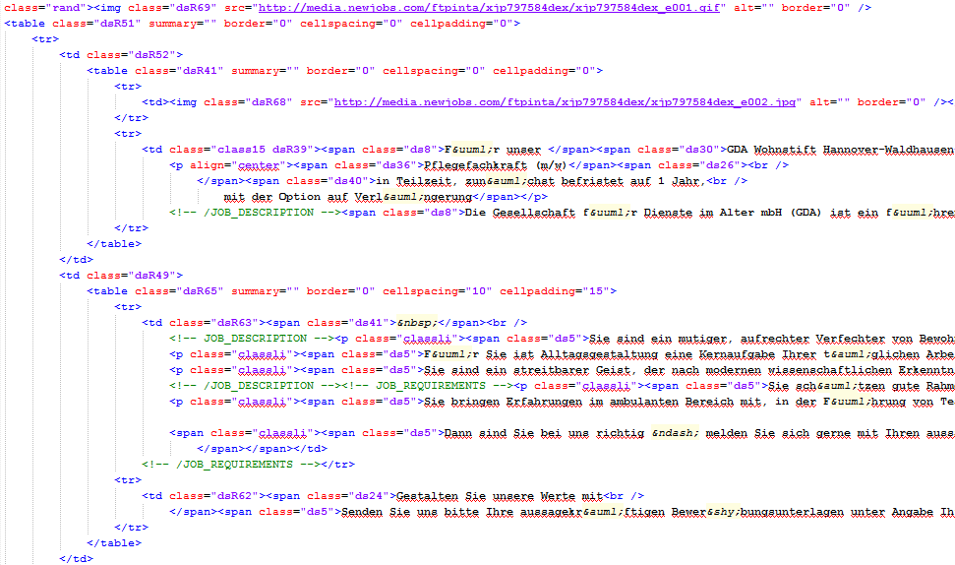
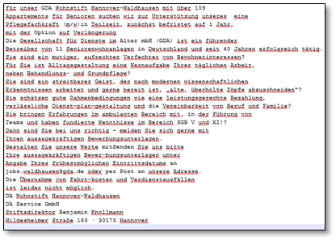

Parsing

Sentence
Segmentation
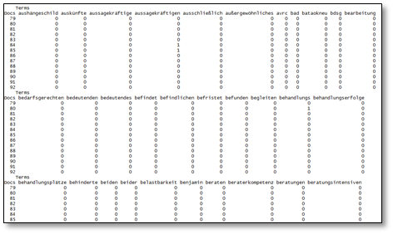
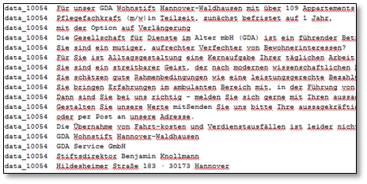
Transformation

Document-by-Term Matrix
One sentence per line text
Figure 2.

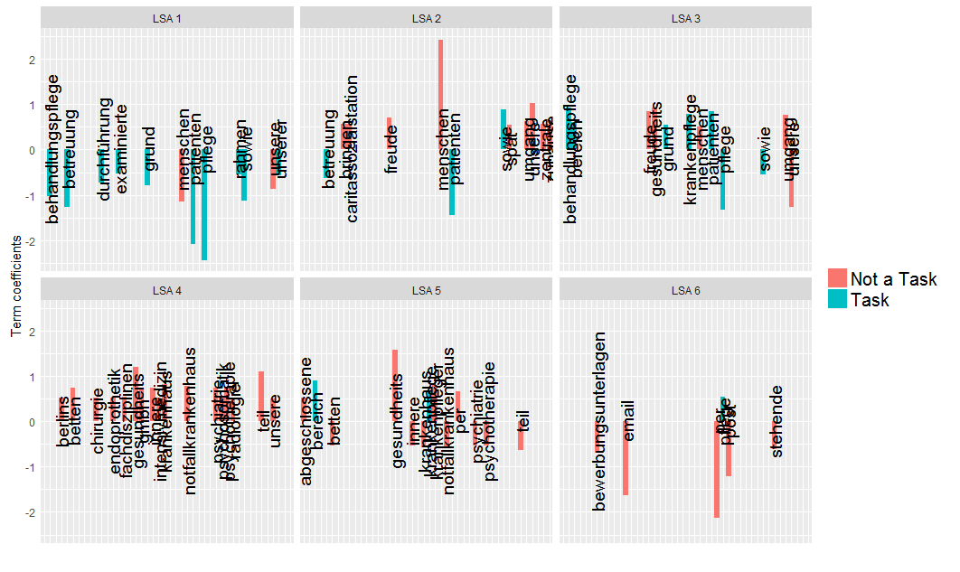
Figure 3

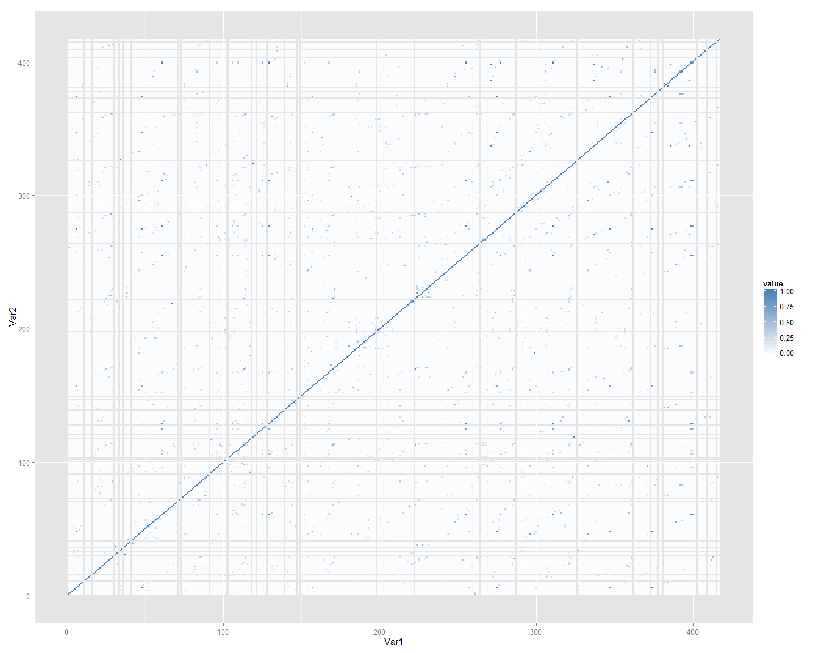

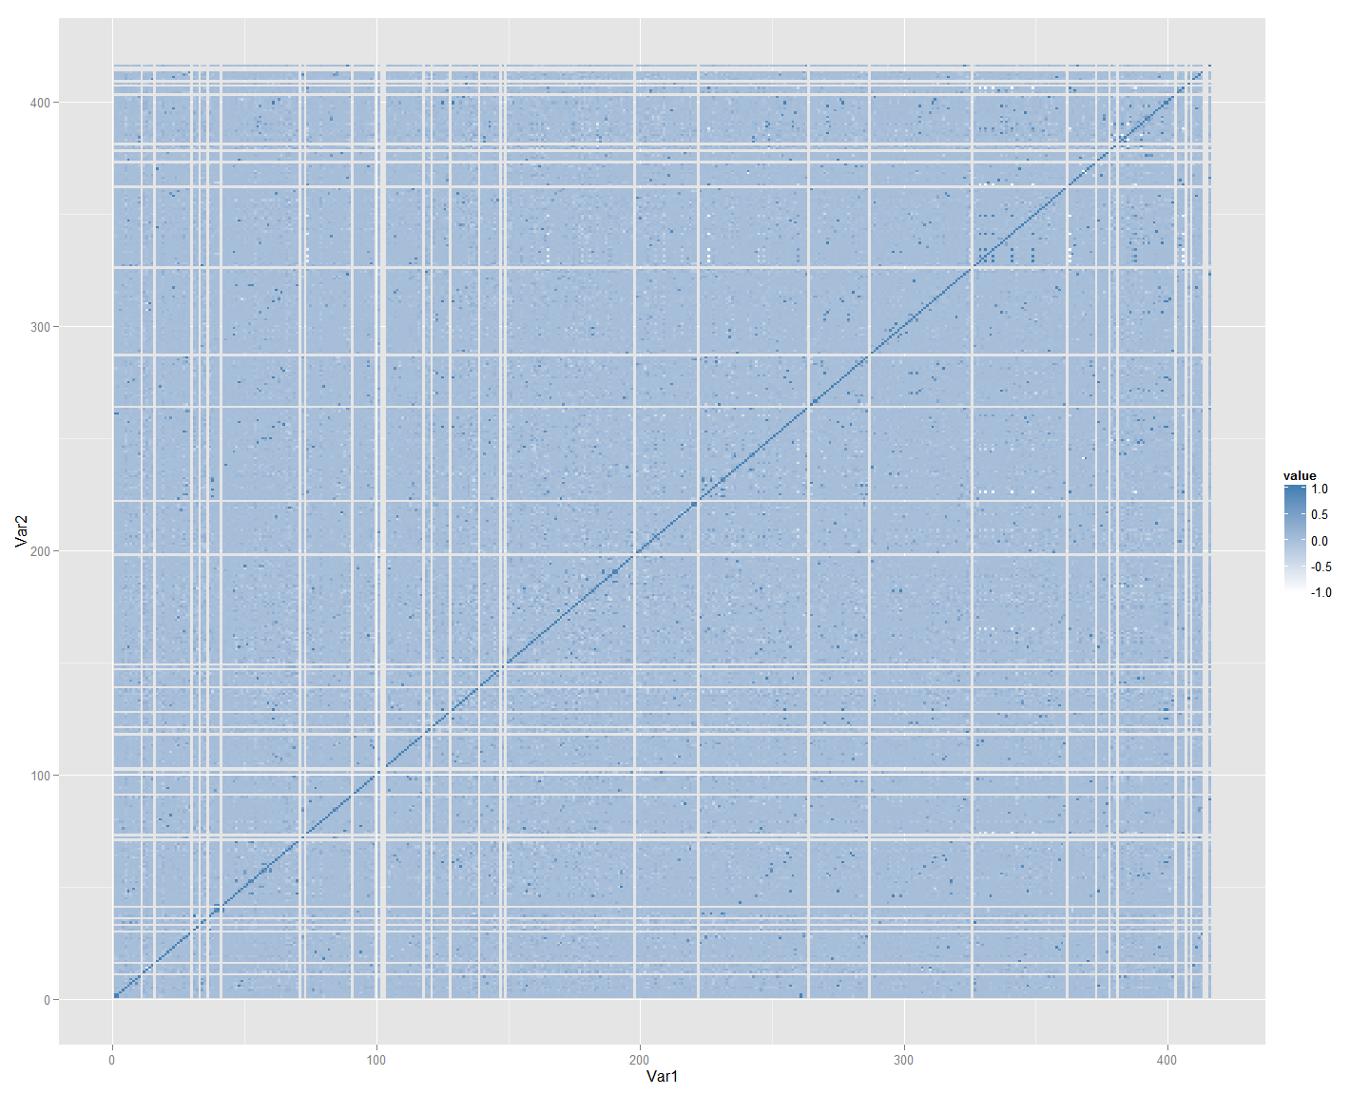
Figure 4.
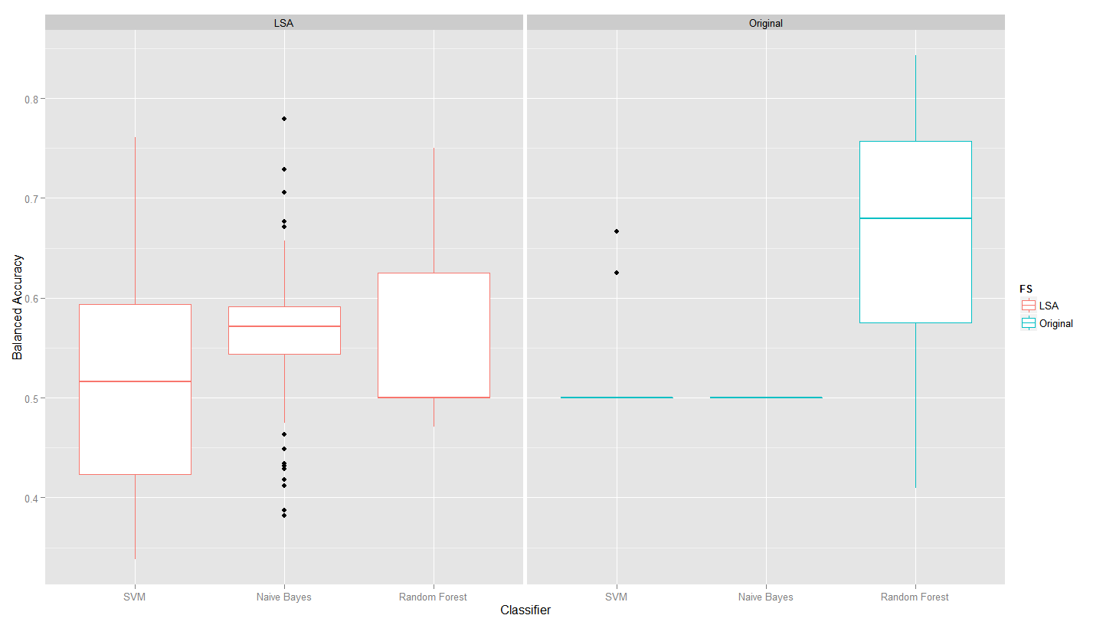

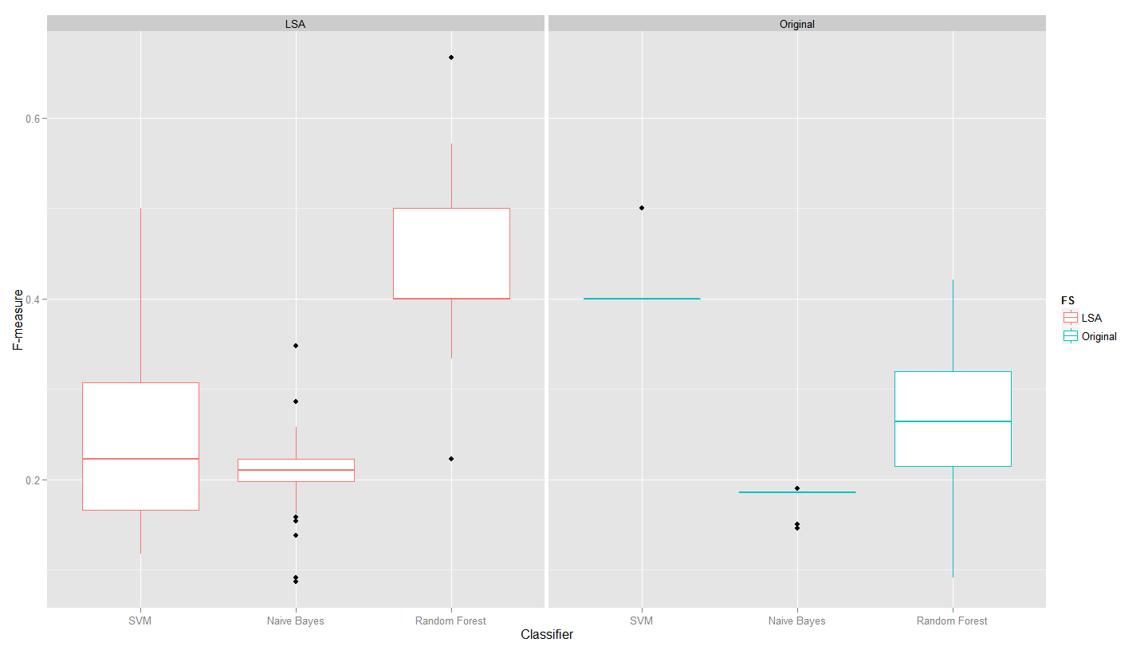

Figure

Table
Table 1
 | Text Preprocessing |  | Text Transformation | Dimensionality Reduction | Classification | Evaluation | Validation
 | Text Preparation | Text Cleaning
Input | Raw html files | Output from Text Preparation | Output from Text Cleaning | Document-by-Term Matrix | Output from Dimensionality Reduction | Classification Model, test data, and an evaluation measure | Classification from the model
Process | Parsing, sentence segmentation | Punctuation, number, and stopword removal, lower case transformation | Word tokenization, constructing the Document-by-Term matrix where the words are the features and the entries are raw frequencies of the words in each document | Latent Semantic Analysis and/or supervised scoring methods for feature selection. | Apply classification algorithms such as Naïve Bayes, Support Vector Machines, or Random Forest | Classify the documents in test data and compare with the actual labels. Calculate the value of the evaluation measure | Compute classification performance using an independent validation data set or compare the classification to the classification of domain experts
Output | Raw text file (one sentence per line) | Raw text file sentences where all letters are in lower cases and without punctuation, number and stopwords. | Document-by-Term matrix | Matrix where the columns are the new set of features or the reduced Document-by-term matrix | Classification Model | Value for the evaluation | Measure of agreement (one can quantify the agreement through the use existing evaluation measure)

http://www.monsterboard.nl/

